**VS 2015, Install Selenium & NUnit**

Follow <https://www.youtube.com/watch?v=ltfECNuxjN0&list=PL6tu16kXT9PqKSouJUV6sRVgmcKs-VCqo&index=4> and add a new project of “Unit Test”

But you need to install NUnit3.TestAdapter to make the test cases show up in Test Explorer

<https://www.youtube.com/watch?v=ltfECNuxjN0&list=PL6tu16kXT9PqKSouJUV6sRVgmcKs-VCqo&index=4>

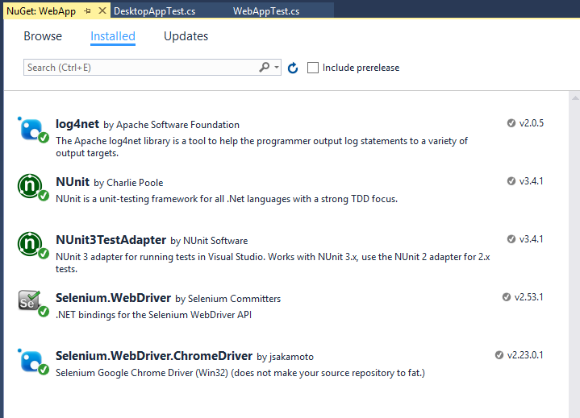

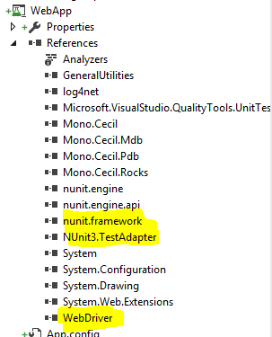

Also make sure you have following NUnit attribute **[TestFixture]** in the code like below

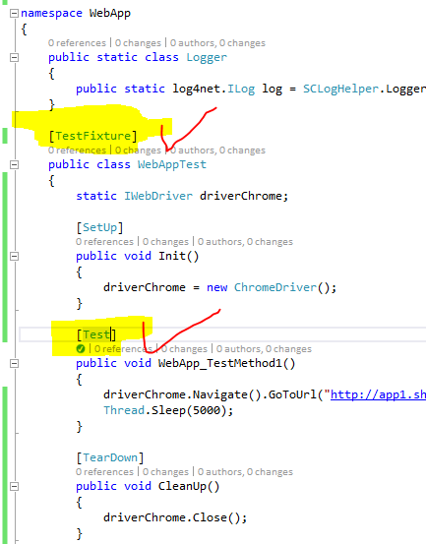

NOT the Visual Studio Unit attributes

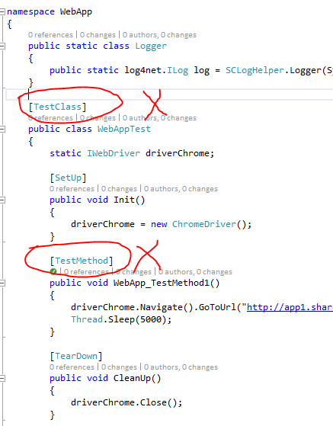

So you will have

